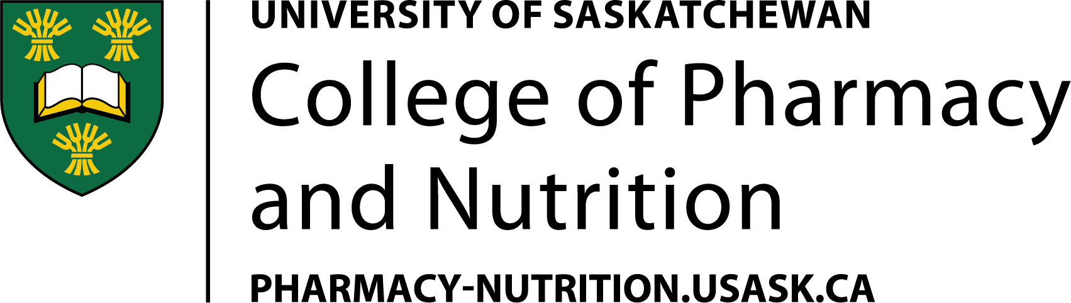

CANDIDACY EXAM REPORT FORM

This form is to be completed during the advisory committee meeting and submitted to CGPS through the College’s Graduate Programs office. A copy will be emailed to the student and all advisory committee members.

Student:
Program:
Program Start Date:
Committee Meeting Date:
Location:

MEETING ATTENDANCE

Chair of the Meeting:
Supervisor(s):
Other Committee Members Present:
Committee Members Absent:
Other Individuals Present:

MEETING MINUTES

The Chair opened the meeting by welcoming attendees and outlining the candidacy exam procedure. The examination began with the first round of questions, led by the cognate, focusing on the student’s literature review. This was followed by a second round of questions related to the student’s assigned research papers. Upon completion of the questioning, the student was asked to leave the room to allow the committee to hold an in-camera discussion regarding the student's performance.

During the in-camera meeting, the committee discussed the following:

OUTCOME (please check one):

☐ PASS – The student has met all requirements of the candidacy exam.
☐ CONDITIONAL PASS – The student is required to address specific deficiencies for re-evaluation by the committee.
☐ INSUFFICIENT – Performance was insufficient in at least one segment (written or oral). Please note: Students and supervisors are asked to follow up with the Chair to discuss available options.

COMMITTEE COMMENTS:

The student was invited back into the room, and the outcome of the examination, along with the committee’s comments, was communicated.

Meeting adjourned at:

Signature of Meeting Chair:

Date:

Distributed on:

